
National University of Computer & Emerging Sciences, Karachi
Spring-2018 CS-Department
MidTerm II
5th April 2018, 09:00 am – 10:00 am
Course Code: CS301 | Course Name: Theory of Automata
Instructor Name: M. Shahzad/Mrs. Shahar Bano/Subhash Sagar
Student Roll No: |  | Section No:
Instructions:
- Return the question paper.
- Read each question completely before answering it. There are 4 questions and 2 pages.
- In case of any ambiguity, you may make assumption. But your assumption should not contradict any statement in the question paper.
- All the answers must be solved according to the sequence given in the question paper.

Time: 60 minutes. Max Marks: 60 points

Question 1a: Provide 2-3 line replies to all of the following short questions. Answer that exceeds 3 lines will not be considered. [10 points]

A) If a language can be expressed in the form of FA than why it is needed to use NFA ?

B) Write down differences between Palindrome and Reverse function? Elaborate with example.

C) what are the conditions of NFA-Null to NFA conversion to recognize the language L.

D) Intersection of two non-regular languages is always non-regular. Is it true or false? Give your statement with proof.

E) L_{k} = {a^{p} : p is any prime number less than a very large given integer k}, L_{k} is a regular language. Is it true or false? Give your statement with proof.

Question 1b: Show that, L = {a^{n}b^{n}c^{n} |n≥ 1} is not regular. Use pumping lemma for at least three cases of y and where i ={1,2}
[05 points]

Question 2: Consider the following NFA- λ, construct an equivalent DFA. Show all steps [15 points]
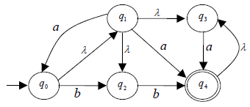
Note: λ represents the empty string.

Question3: Derive the RE for the language accepted the following nfa. For full credit show all the steps clearly.
[Hint: Use approach discussed in Kleen's Theorem] [15 points]

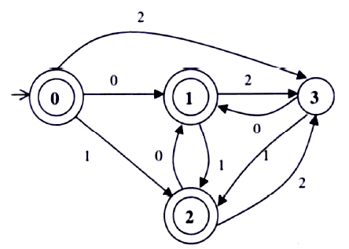

Question 4: Minimize the following DFA using either partitioning method or TF Algorithm: [15 points]

